**Java Spring Boot Application for AWS Resource Management**

**Overview**

This Spring Boot application communicates with AWS services to discover and manage AWS resources such as EC2 instances and S3 buckets. The application provides several REST APIs for these operations, allowing asynchronous discovery and persistence of resource data into a database.

**Database**

In this application we have used H2 Database, which starts up as the application server is started. The database properties are mentioned below :

spring.datasource.url= jdbc:h2:mem:awsapp

spring.datasource.driverClassName= org.h2.Driver

spring.datasource.username= nimesa

spring.datasource.password= nimesa

**Note :** This Spring Boot application demonstrates how to interact with AWS services, discover resources asynchronously, and manage them using REST APIs. The application uses Spring Data JPA for database operations and AWS SDK for interacting with AWS services. The provided endpoints facilitate the discovery and management of EC2 instances and S3 buckets, offering functionalities to track and retrieve the discovery results.

**API Endpoints**

1. **Discover Services**

URL : /aws/discover-services

Method : POST

Description : Initiates the discovery of specified AWS services asynchronously. Currently supports EC2 and S3 services.

Input: ["EC2", "S3"]

Output: [JobId : 1]

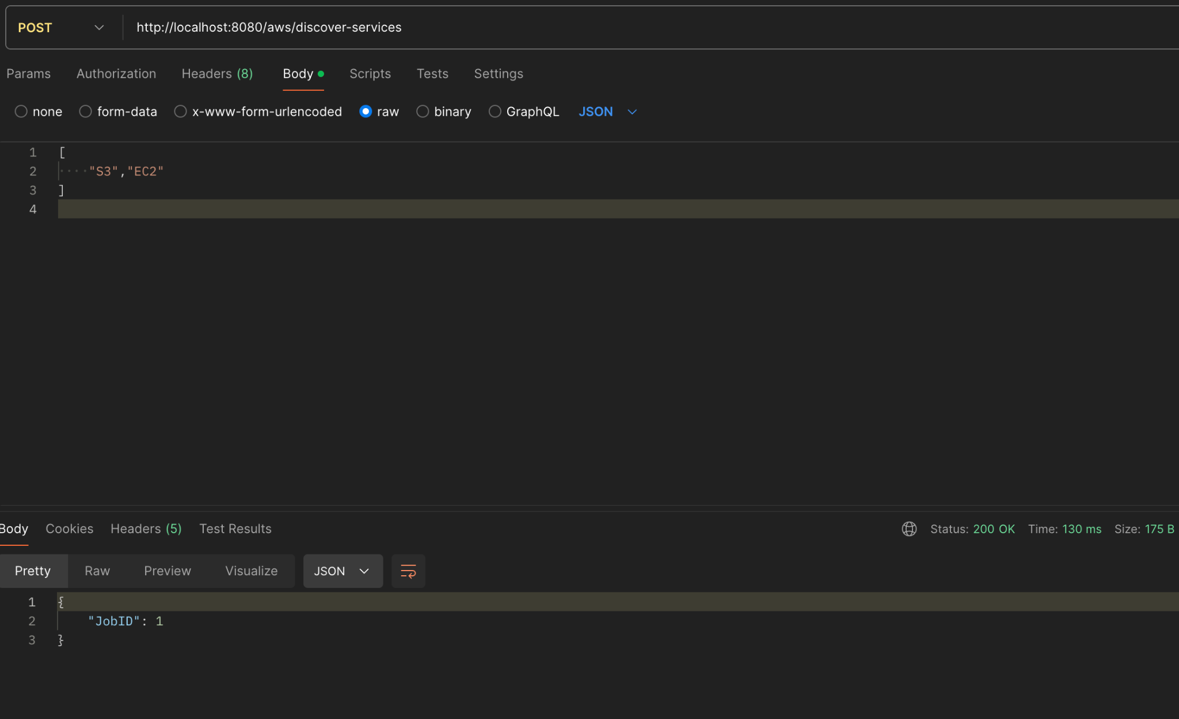

1. **Get Job Result**

URL: /aws/job-result/{jobId}

Method: GET

Description: Retrieves the status of a specific job.

Input: JobId (Path Variable)

Output: [Status : Success]

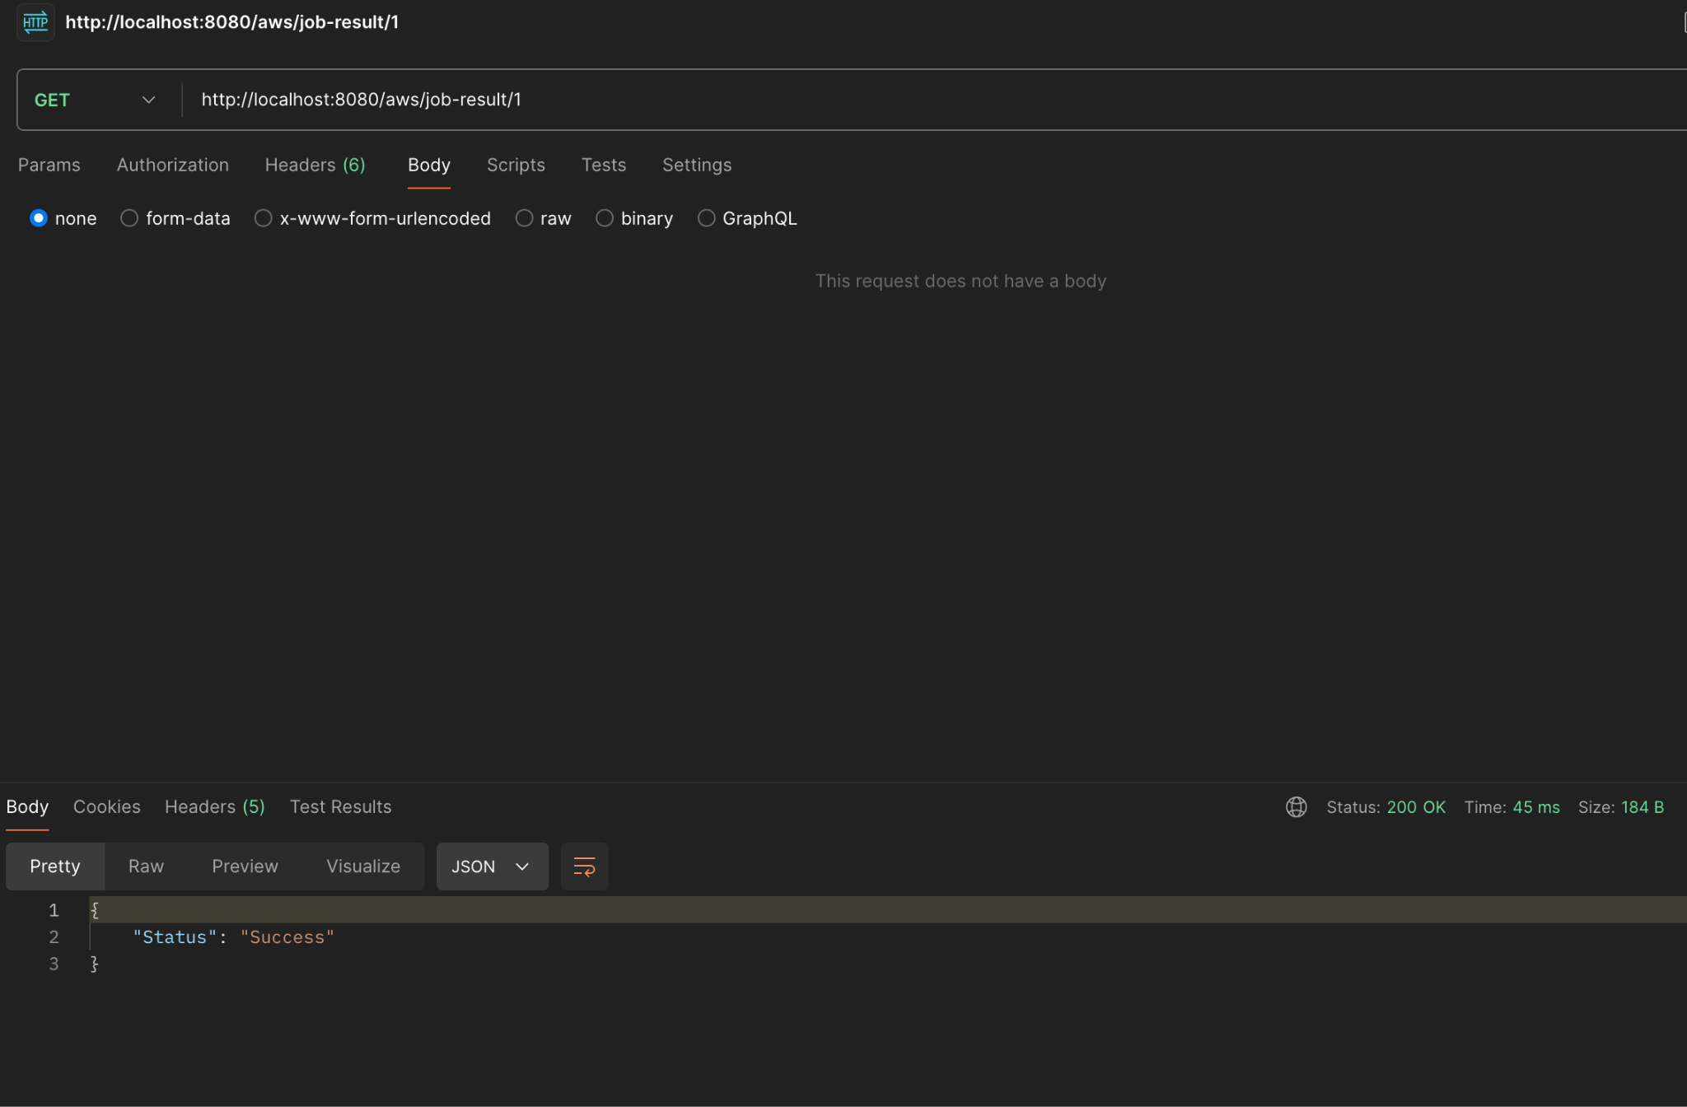

1. **Get Discovered S3 Buckets And EC2 Instances**

URL: /aws/discovery-result/{service}

Method: GET

Description: Returns a list of discovered S3 bucket names or EC2 Instance Ids based on the input parameter..

Input: “EC2” or “S3” (Path Variable)

Output: List of S3 bucket names/EC2 instance ids

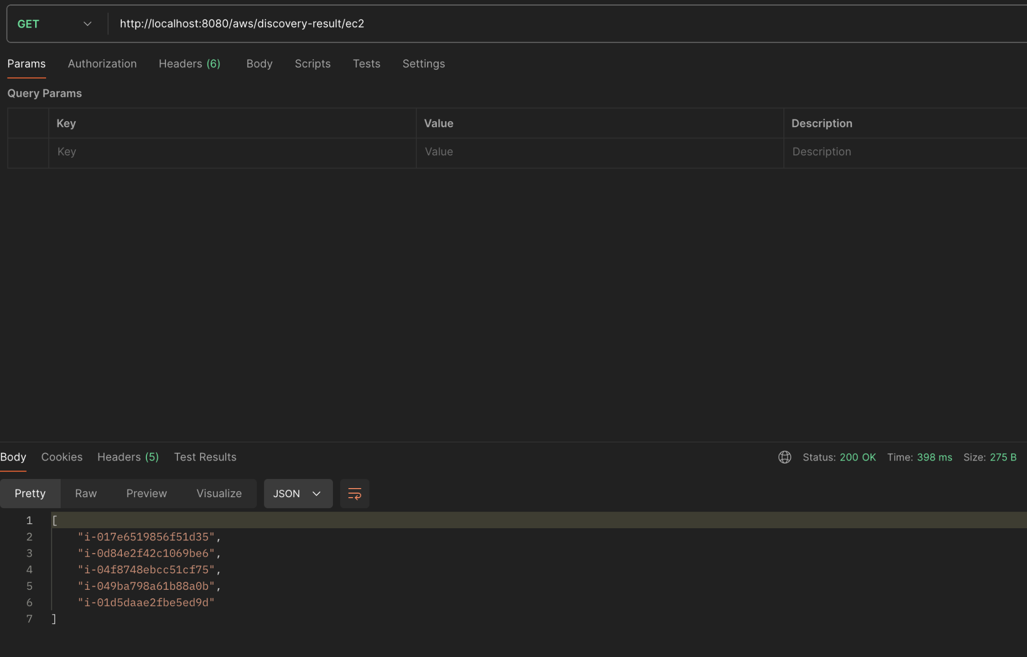

1. **S3 Bucket Objects List**

URL: aws/discover-s3-bucket-objects/{bucketName}

Method: POST

Description: Discovers all the File Names in the S3 bucket and saves in the DB. Return the JobID as it may take time for the job the complete

Input: S3 Bucket Name

Output: [JobID : 2]

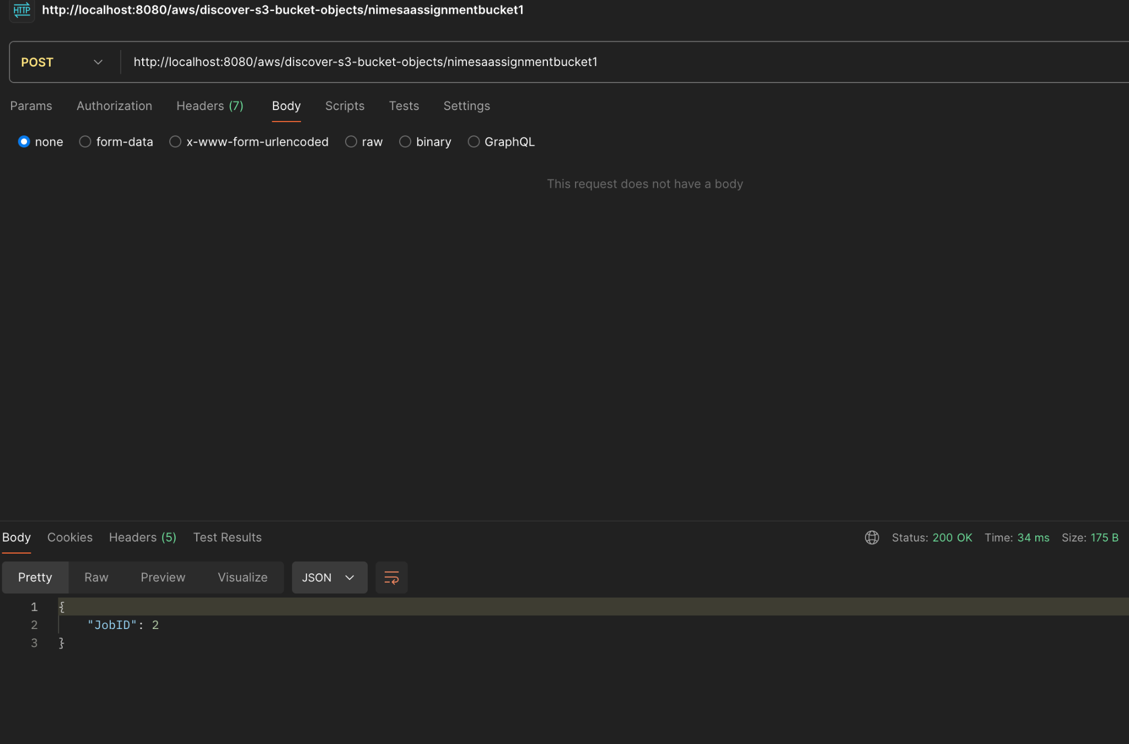

1. **Get S3 Bucket Objects Count**

URL: aws/s3-bucket-objects-count/{bucketName}

Method: GET

Description: Retrieves the count of objects within a specified S3 bucket from the database.

Input: Bucket Name (Path Variable)

Output: [Count : 6]

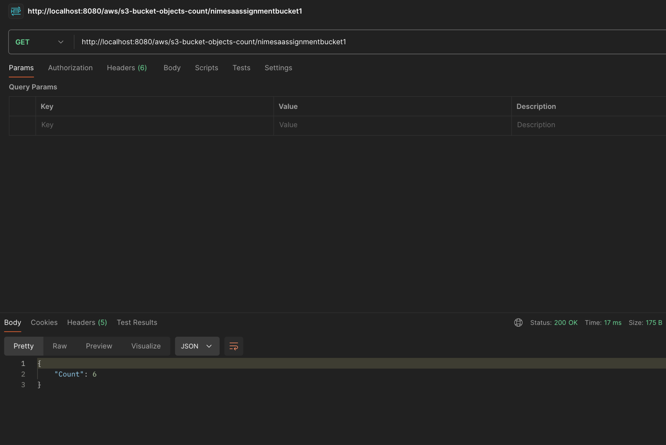

1. **Get S3 Bucket Objects Matching a Given Pattern**

URL: /aws/s3-bucket-objects/{bucketName}/{pattern}

Method: GET

Description: Retrieves a list of object keys within a specified S3 bucket that match a given pattern. The results are fetched from the database.

Input: Bucket Name, Pattern = “Test”

Output: ["New folder/Test-File.txt", "New folder/Test-File - 2.txt"]

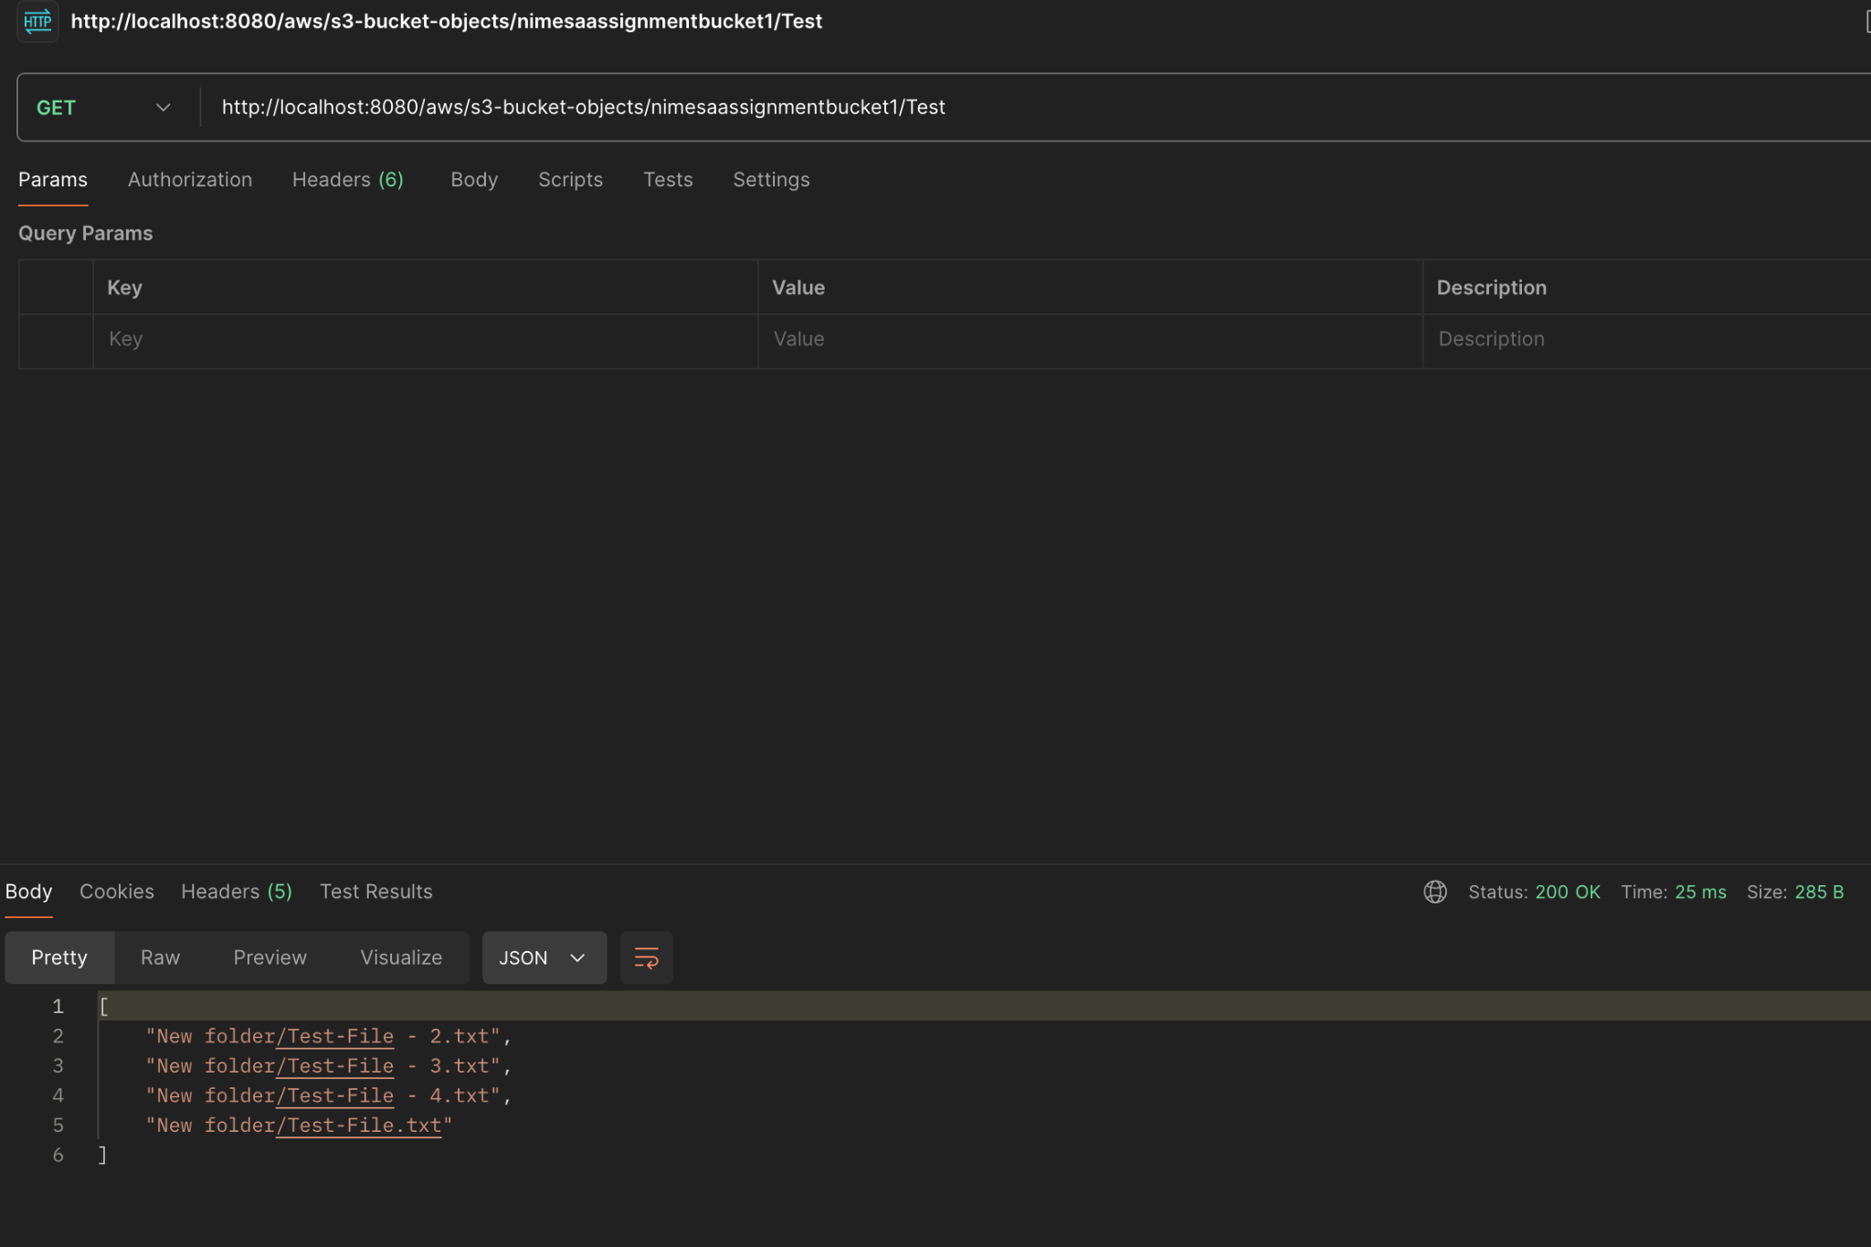

**Database Tables**

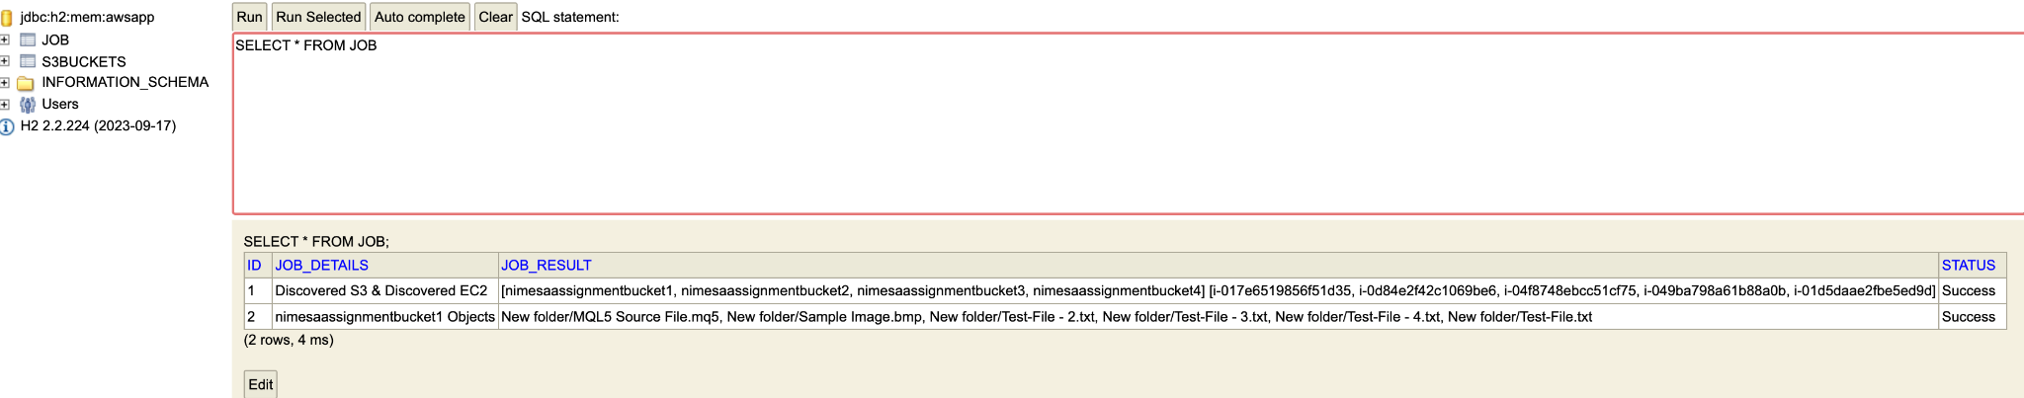

Job Table

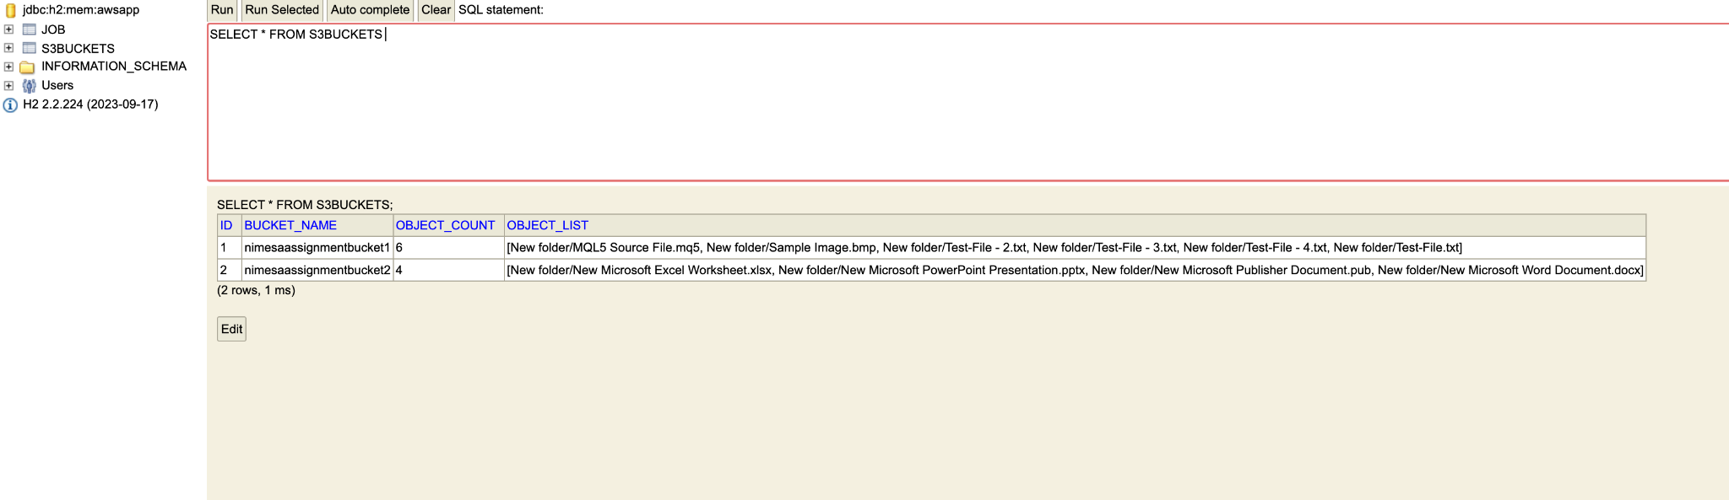

S3 Buckets Table